**Thesis Results**

**Honesty**

**Iraq.**

|  |  |  |
| --- | --- | --- |
| Date |  | Honesty |
| March 6, 1998 | 10291.15 | 1.70 |
| May 25, 2000 | 11102.65 | -3.29 |
| August 6, 2002 | 11905.60 | 2.65 |
| August 18, 2008 | 14109.44 | -0.08 |
| December 1, 2009 | 14579.25 | 1.58 |
| August 25, 2011 | 15211.36 | -0.32 |
| August 26, 2012 | 15578.66 | 0.40 |
| September 6, 2013 | 15954.51 | -0.20 |

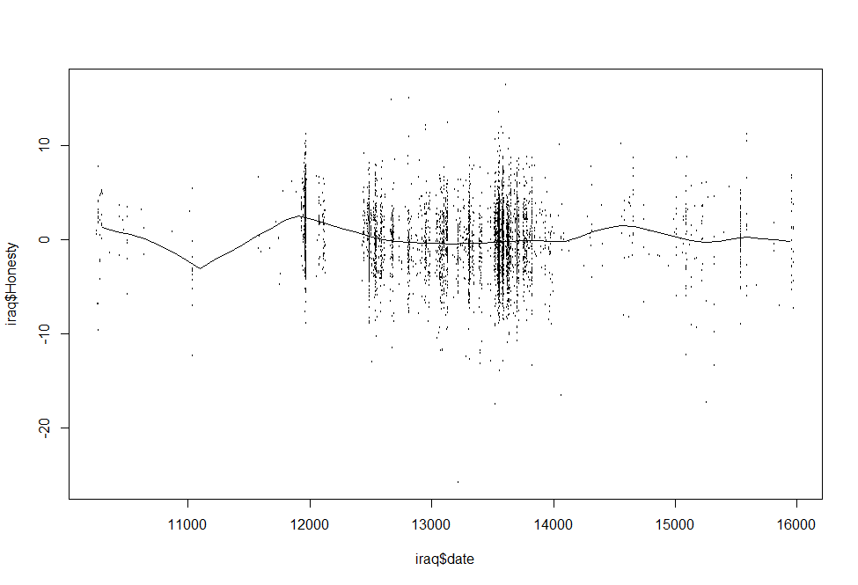

**Democrats**

|  |  |  |
| --- | --- | --- |
| Date |  | Honesty |
| April 27, 1998 | 10343.44 | 1.94 |
| June 9, 2000 | 11117.97 | -0.56 |
| October 7, 2001 | 11602.05 | 0.75 |
| May 8, 2002 | 11815.05 | 3.13 |
| October 17, 2005 | 13073.66 | -0.44 |
| August 18, 2008 | 14109.59 | -0.08 |
| February 11, 2010 | 14651.76 | 2.77 |
| August 27, 2011 | 15213.29 | -0.08 |
| September 20, 2013 | 15968.46 | -1.15 |

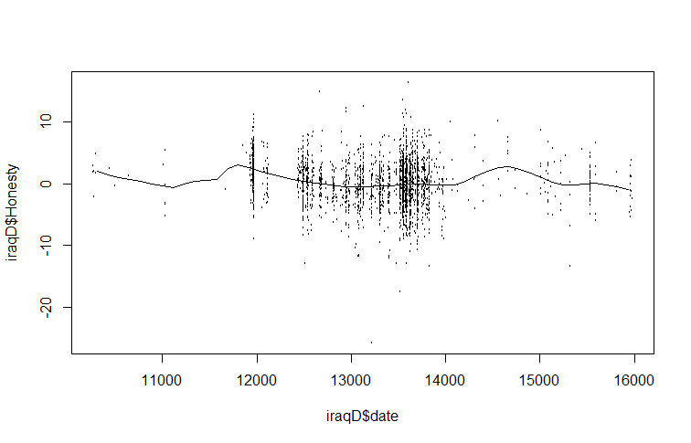**Republicans**

|  |  |  |
| --- | --- | --- |
| Date |  | Honesty |
| 3/23/1998 | 10308.19 | 1.248168 |
| 6/5/2000 | 11113.46 | -4.67931 |
| 9/8/2002 | 11938.12 | 2.068895 |
| 11/5/2005 | 13092.66 | -0.39329 |
| 3/8/2008 | 13946.43 | 0.062673 |
| 7/31/2008 | 14091.96 | -0.57567 |
| 2/14/2010 | 14654.67 | 0.8834 |
| 9/10/2011 | 15227.09 | -0.66686 |
| 8/28/2013 | 15945.03 | 0.8834 |

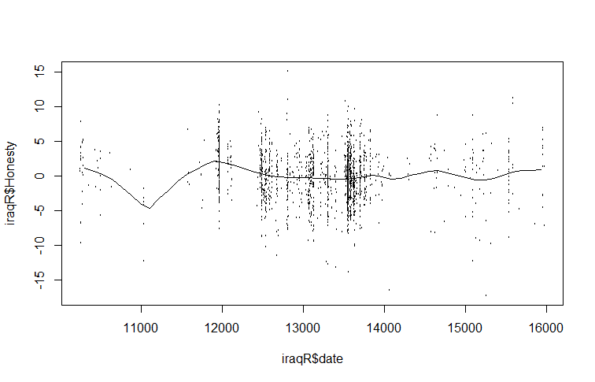 **Iran and North Korea.**

|  |  |  |
| --- | --- | --- |
| Date |  | Honesty |
| 7/6/1998 | 10413.61 | 1.539577 |
| 1/23/2000 | 10979.04 | -0.43606 |
| 8/19/2001 | 11553.9 | 1.012742 |
| 9/12/2003 | 12307.81 | -3.20194 |
| 12/3/2006 | 13485.8 | -1.0946 |
| 12/19/2009 | 14597.82 | -0.17264 |
| 3/9/2012 | 15408.27 | -1.35802 |
| 6/23/2013 | 15879.47 | 3.251791 |

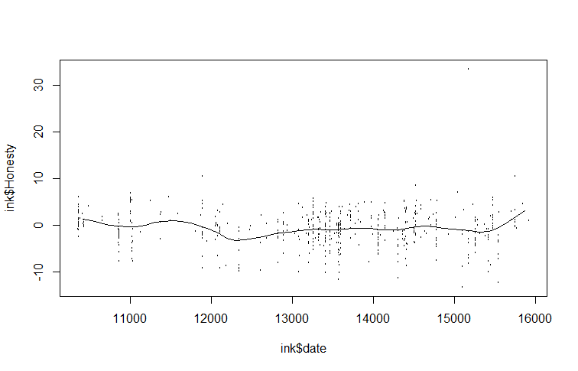

**Democrats**

|  |  |  |
| --- | --- | --- |
| Date |  | Honesty |
| 6/27/1998 | 10404.19 | 1.012742 |
| 9/3/1999 | 10837.69 | 0.09078 |
| 6/24/2001 | 11497.36 | 1.539577 |
| 2/26/2003 | 12109.91 | -0.56776 |
| 12/6/2003 | 12392.63 | -2.14827 |
| 11/26/2007 | 13843.91 | -0.43605 |
| 12/26/2008 | 14239.71 | -2.01656 |
| 8/24/2011 | 15210.37 | -0.56776 |
| 8/16/2012 | 15568.48 | -1.48973 |
| 8/19/2013 | 15936.01 | 1.012742 |

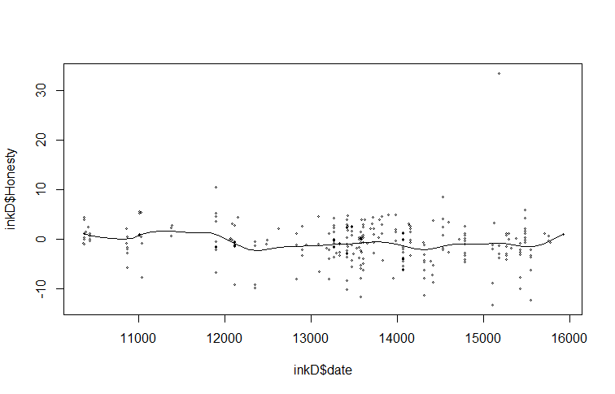

**Republicans**

|  |  |  |
| --- | --- | --- |
| Date |  | Honesty |
| 6/5/1998 | 10382.69 | 1.876729 |
| 12/15/1999 | 10940.19 | -0.98092 |
| 4/29/2001 | 11441.94 | 1.060258 |
| 12/3/2003 | 12389.69 | -4.5384 |
| 4/15/2006 | 13253.81 | -0.51436 |
| 2/16/2007 | 13560.43 | -1.50579 |
| 2/7/2010 | 14647.55 | 0.710342 |
| 10/4/2011 | 15251.51 | -1.85571 |
| 5/30/2013 | 15855.47 | 4.909335 |

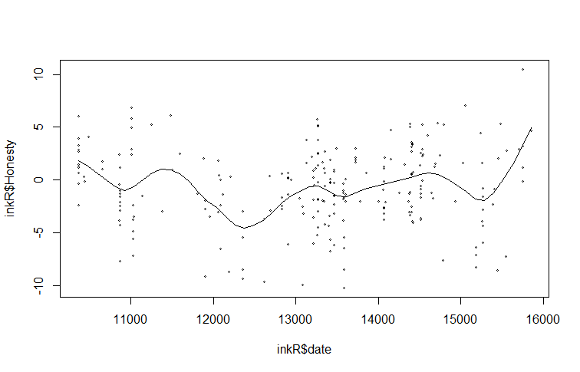

**Status**

**Iraq.**

|  |  |  |
| --- | --- | --- |
| Date |  | Status |
| 3/3/1998 | 10288.81 | -0.29998 |
| 2/16/1999 | 10638.33 | 1.09708 |
| 10/17/1999 | 10881.05 | -1.39767 |
| 9/20/2000 | 11220.85 | 2.494141 |
| 1/25/2001 | 11347.07 | 0.348655 |
| 5/11/2001 | 11453.86 | 0.548235 |
| 9/15/2001 | 11580.08 | -0.1004 |
| 5/6/2002 | 11813.09 | -0.05051 |
| 9/28/2002 | 11958.72 | -0.54946 |
| 3/22/2003 | 12133.48 | -0.25009 |
| 2/18/2005 | 12832.5 | -0.39977 |
| 6/24/2005 | 12958.72 | -0.00061 |
| 3/13/2006 | 13220.85 | -0.00061 |
| 9/24/2006 | 13415.03 | 0.448445 |
| 4/9/2008 | 13978.14 | 0.49834 |
| 12/7/2008 | 14220.85 | -0.34988 |
| 7/9/2009 | 14434.45 | 0.348655 |
| 2/27/2010 | 14667.46 | -1.29788 |
| 7/13/2010 | 14803.38 | 0.149074 |
| 2/11/2011 | 15016.97 | -0.25009 |
| 9/23/2011 | 15240.27 | 1.146975 |
| 6/1/2012 | 15492.7 | -0.74904 |
| 10/5/2012 | 15618.91 | 0.8975 |
| 3/19/2013 | 15783.96 | 0.548235 |
| 9/1/2013 | 15949.01 | 0.747815 |

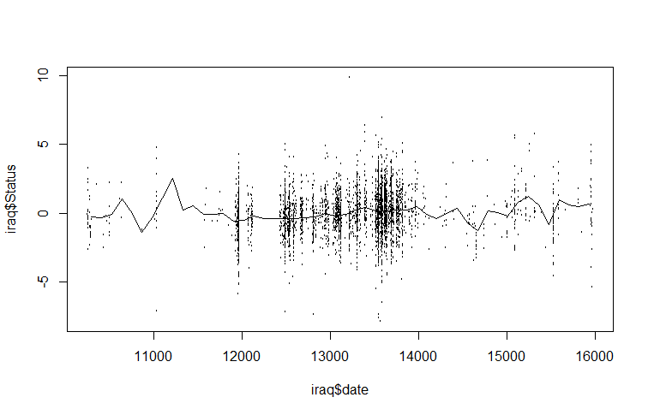

**Democrats**

|  |  |  |
| --- | --- | --- |
| Date |  | Status |
| 4/8/1998 | 10324.08 | -0.39977 |
| 7/23/1998 | 10430.58 | -1.34778 |
| 11/16/1998 | 10546.75 | -1.34778 |
| 3/12/1999 | 10662.93 | -0.44967 |
| 5/21/2000 | 11098.61 | -0.84883 |
| 3/8/2001 | 11389.06 | -0.59935 |
| 8/19/2001 | 11553.64 | -0.29998 |
| 5/17/2002 | 11824.73 | -1.34778 |
| 5/30/2003 | 12202.31 | -0.29998 |
| 11/30/2003 | 12386.26 | -0.00061 |
| 6/1/2004 | 12570.21 | -0.29998 |
| 11/3/2004 | 12725.12 | -0.05051 |
| 2/27/2005 | 12841.3 | -0.1004 |
| 6/23/2005 | 12957.48 | 0.149074 |
| 1/22/2006 | 13170.47 | -0.05051 |
| 9/2/2006 | 13393.15 | 0.49834 |
| 4/12/2007 | 13615.83 | 0.248865 |
| 4/14/2008 | 13983.73 | 0.747815 |
| 10/15/2008 | 14167.68 | 0.049284 |
| 7/23/2009 | 14448.44 | 0.648025 |
| 3/22/2010 | 14690.48 | -2.19599 |
| 10/21/2010 | 14903.48 | 0.049284 |
| 2/4/2011 | 15009.98 | -0.34988 |
| 9/25/2011 | 15242.34 | 1.146975 |
| 1/19/2012 | 15358.52 | 0.747815 |
| 5/24/2012 | 15484.38 | -1.69704 |
| 9/7/2012 | 15590.87 | 0.19897 |
| 12/23/2012 | 15697.37 | 0.448445 |
| 4/28/2013 | 15823.23 | 1.29666 |
| 9/1/2013 | 15949.09 | 0.29876 |

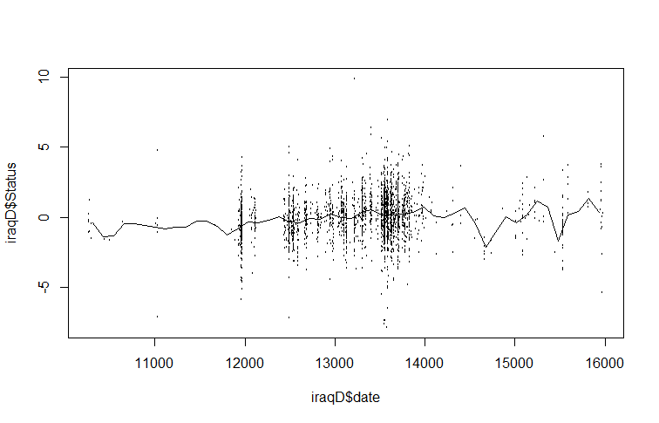

**Republican**

|  |  |  |
| --- | --- | --- |
| Date |  | Status |
| 4/11/1998 | 10327.6 | -0.24448 |
| 10/22/1998 | 10521.64 | 0.304695 |
| 2/25/1999 | 10647.76 | 1.769161 |
| 10/6/1999 | 10870.91 | -1.08655 |
| 5/26/2000 | 11103.75 | 2.464783 |
| 1/24/2001 | 11346.3 | -0.02481 |
| 5/11/2001 | 11453.02 | -4.01548 |
| 1/8/2002 | 11695.57 | 0.560976 |
| 8/10/2002 | 11909.02 | -0.53737 |
| 7/5/2003 | 12238.88 | -0.53737 |
| 11/28/2003 | 12384.41 | -0.97671 |
| 7/8/2004 | 12607.56 | -0.39093 |
| 2/16/2005 | 12830.7 | -0.64721 |
| 10/7/2005 | 13063.55 | -0.20787 |
| 1/31/2006 | 13179.97 | -0.39093 |
| 3/25/2007 | 13597.16 | 0.19486 |
| 7/19/2007 | 13713.58 | 0.048413 |
| 12/31/2007 | 13878.51 | 0.085025 |
| 3/18/2008 | 13956.13 | -0.02481 |
| 7/31/2008 | 14091.96 | 0.304695 |
| 4/10/2009 | 14344.21 | -0.50076 |
| 8/4/2009 | 14460.63 | -0.46415 |
| 11/19/2009 | 14567.35 | -0.06142 |
| 3/15/2010 | 14683.78 | -1.01333 |
| 6/20/2010 | 14780.8 | 0.341306 |
| 10/5/2010 | 14887.52 | -0.09803 |
| 2/28/2011 | 15033.05 | 0.19486 |
| 6/5/2011 | 15130.07 | 1.29321 |
| 10/9/2011 | 15256.19 | 1.51288 |
| 4/29/2012 | 15459.93 | -0.20787 |
| 8/24/2012 | 15576.36 | -0.35432 |
| 1/7/2013 | 15712.18 | 0.487753 |
| 5/3/2013 | 15828.61 | -0.75704 |
| 8/18/2013 | 15935.33 | 1.000316 |

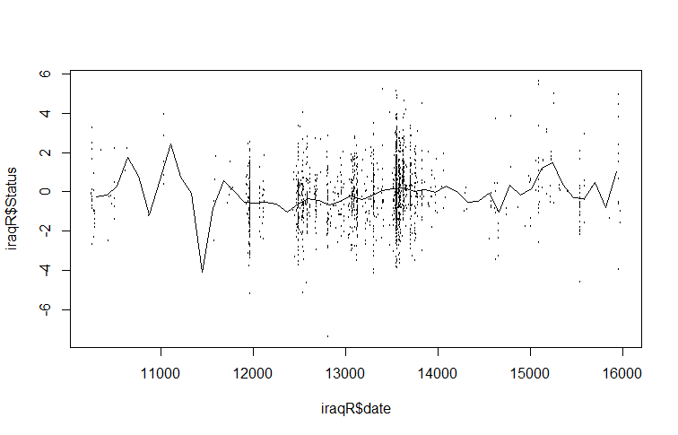

**Iran and North Korea.**

|  |  |  |
| --- | --- | --- |
| Date |  | Status |
| 8/3/1998 | 10441.88 | -0.3882 |
| 11/6/1998 | 10536.12 | -0.3882 |
| 4/15/1999 | 10696.33 | 0.449125 |
| 1/13/2000 | 10969.62 | -0.3882 |
| 5/5/2000 | 11082.71 | 0.867786 |
| 12/8/2000 | 11299.46 | -0.44801 |
| 3/31/2001 | 11412.54 | 0.389316 |
| 11/22/2001 | 11648.14 | -1.88342 |
| 7/6/2002 | 11874.31 | 1.047213 |
| 2/17/2003 | 12100.49 | 0.867786 |
| 9/12/2003 | 12307.81 | 2.183579 |
| 4/25/2004 | 12533.99 | -0.56762 |
| 3/12/2005 | 12854.4 | 0.150081 |
| 10/5/2005 | 13061.72 | -0.3882 |
| 3/14/2006 | 13221.93 | 0.090273 |
| 6/17/2006 | 13316.17 | -0.14896 |
| 2/26/2007 | 13570.61 | 0.748169 |
| 9/12/2007 | 13768.52 | -0.74705 |
| 7/19/2008 | 14079.5 | 0.568743 |
| 10/31/2008 | 14183.17 | 0.20989 |
| 3/30/2009 | 14333.95 | 0.68836 |
| 9/16/2009 | 14503.58 | -0.08915 |
| 5/29/2010 | 14758.02 | 1.16683 |
| 12/3/2010 | 14946.5 | 0.269699 |
| 5/3/2011 | 15097.28 | 0.927595 |
| 8/14/2011 | 15200.95 | 0.090273 |
| 4/15/2012 | 15445.97 | 0.807978 |
| 2/20/2013 | 15756.96 | -1.28533 |
| 6/4/2013 | 15860.62 | -0.20877 |

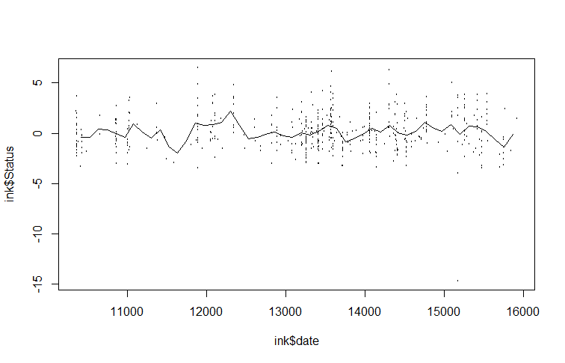

**Democrats**

|  |  |  |
| --- | --- | --- |
| Date |  | Status |
| 5/20/1998 | 10366.49 | -0.42615 |
| 9/10/1998 | 10479.58 | -1.19519 |
| 8/25/1999 | 10828.26 | 0.638683 |
| 1/23/2000 | 10979.04 | -0.24868 |
| 4/16/2000 | 11063.86 | -0.18952 |
| 7/29/2000 | 11167.52 | 0.638683 |
| 11/10/2000 | 11271.19 | -0.01205 |
| 2/21/2001 | 11374.85 | 0.28374 |
| 6/14/2001 | 11487.93 | -15.5704 |
| 10/15/2001 | 11610.45 | 0.224582 |
| 6/8/2002 | 11846.04 | 0.875312 |
| 1/29/2003 | 12081.64 | 0.69784 |
| 8/6/2003 | 12270.12 | 1.76267 |
| 12/25/2003 | 12411.48 | 1.171098 |
| 5/5/2004 | 12543.41 | -0.78109 |
| 8/26/2004 | 12656.5 | -0.66278 |
| 3/31/2005 | 12873.25 | 0.756997 |
| 11/2/2005 | 13090 | -0.0712 |
| 2/24/2006 | 13203.08 | 0.402054 |
| 6/17/2006 | 13316.17 | -0.24868 |
| 10/8/2006 | 13429.26 | -0.18952 |
| 2/7/2007 | 13551.77 | 0.579526 |
| 9/21/2007 | 13777.94 | -0.78109 |
| 8/26/2008 | 14117.2 | 0.165425 |
| 3/30/2009 | 14333.95 | 2.117614 |
| 11/2/2009 | 14550.7 | -1.31351 |
| 6/16/2010 | 14776.87 | 1.34857 |
| 2/7/2011 | 15012.47 | 2.4134 |
| 9/12/2011 | 15229.22 | 0.106268 |
| 1/22/2012 | 15361.15 | 0.638683 |
| 8/16/2012 | 15568.48 | 0.934469 |
| 1/4/2013 | 15709.84 | -0.72193 |
| 7/31/2013 | 15917.16 | 1.466884 |

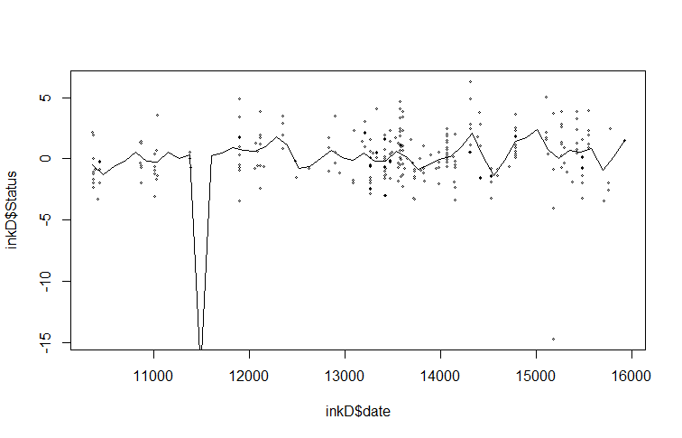

**Republicans**

|  |  |  |
| --- | --- | --- |
| Date |  | Status |
| 5/27/1998 | 10373.4 | 0.161296 |
| 9/15/1998 | 10484.9 | -0.96465 |
| 4/26/1999 | 10707.9 | 0.583525 |
| 11/26/1999 | 10921.61 | -0.09204 |
| 3/17/2000 | 11033.11 | 0.47093 |
| 11/4/2000 | 11265.4 | -0.14834 |
| 2/23/2001 | 11376.9 | 1.090199 |
| 10/4/2001 | 11599.9 | -2.82245 |
| 8/26/2002 | 11925.1 | 1.315388 |
| 4/6/2003 | 12148.1 | 0.836862 |
| 11/15/2003 | 12371.1 | 2.46948 |
| 11/11/2004 | 12733.48 | -0.68316 |
| 3/12/2005 | 12854.27 | -0.57057 |
| 6/3/2005 | 12937.89 | -0.17649 |
| 1/12/2006 | 13160.89 | -0.59872 |
| 5/13/2006 | 13281.68 | -0.40168 |
| 12/13/2006 | 13495.39 | 0.780565 |
| 4/13/2007 | 13616.18 | 0.66797 |
| 8/11/2007 | 13736.97 | -0.85205 |
| 7/2/2008 | 14062.18 | 0.639822 |
| 10/3/2008 | 14155.1 | -0.48612 |
| 2/28/2009 | 14303.76 | -0.62686 |
| 6/20/2009 | 14415.26 | -0.42982 |
| 8/24/2009 | 14480.3 | 0.189445 |
| 5/2/2010 | 14731.18 | 0.302039 |
| 8/21/2010 | 14842.68 | 0.133147 |
| 11/22/2010 | 14935.59 | -0.62686 |
| 4/1/2011 | 15065.68 | -0.26093 |
| 7/31/2011 | 15186.47 | 1.371685 |
| 3/10/2012 | 15409.47 | -0.48612 |
| 8/15/2012 | 15567.43 | -0.48612 |
| 1/29/2013 | 15734.67 | -1.38688 |
| 5/2/2013 | 15827.59 | -1.64021 |

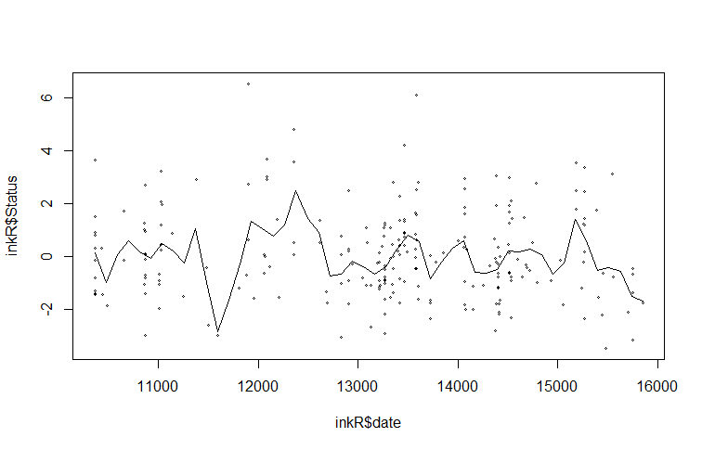

**Categorical Thinking**

**Iraq.**

|  |  |  |
| --- | --- | --- |
| Date |  | CatThink |
| 3/13/1998 | 10298.52 | 0.6414549 |
| 10/13/1998 | 10512.12 | -0.0707631 |
| 3/7/1999 | 10657.75 | 0.0388089 |
| 1/12/2000 | 10968.43 | -1.1116971 |
| 5/27/2000 | 11104.35 | -3.3579232 |
| 9/24/2001 | 11589.79 | 1.0249569 |
| 4/16/2002 | 11793.67 | 0.4223109 |
| 8/20/2002 | 11919.88 | 0.7510269 |
| 4/10/2003 | 12152.89 | 0.1483809 |
| 1/4/2006 | 13152.89 | 0.4223109 |
| 7/15/2008 | 14075.22 | -0.3446931 |
| 3/9/2010 | 14677.17 | 2.0111049 |
| 6/27/2011 | 15152.89 | -0.3446931 |
| 6/11/2012 | 15502.41 | 0.5318829 |
| 9/10/2013 | 15958.72 | -0.5090511 |

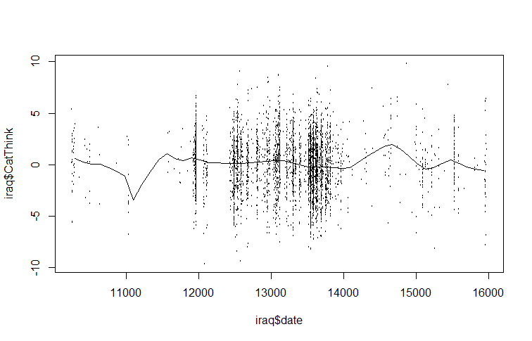

**Democrats**

|  |  |  |
| --- | --- | --- |
| Date |  | CatThink |
| 3/19/1998 | 10304.71 | 1.8529283 |
| 6/9/2000 | 11117.97 | -2.470499 |
| 9/8/2001 | 11573.01 | -0.741128 |
| 8/22/2002 | 11921.54 | 0.9882428 |
| 2/15/2004 | 12463.71 | 0.0154716 |
| 1/22/2006 | 13170.47 | 0.5018572 |
| 3/16/2008 | 13954.68 | -0.092614 |
| 3/12/2010 | 14680.8 | 3.5282565 |
| 6/30/2011 | 15155.2 | -0.092614 |
| 10/24/2011 | 15271.38 | -0.038571 |
| 7/2/2012 | 15523.1 | 0.4478143 |
| 9/20/2013 | 15968.46 | -1.605814 |

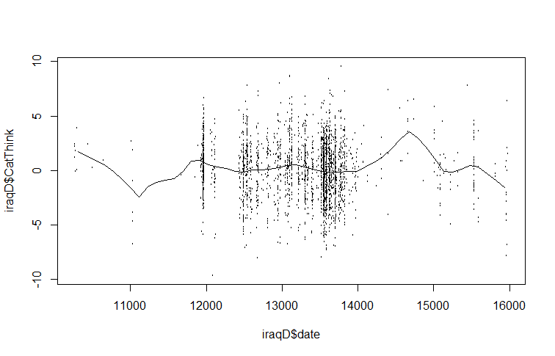

**Republicans**

|  |  |  |
| --- | --- | --- |
| Date |  | CatThink |
| 4/1/1998 | 10317.9 | 0.2878837 |
| 5/26/2000 | 11103.75 | -2.7360069 |
| 9/23/2001 | 11588.85 | 0.9898584 |
| 10/7/2002 | 11967.23 | 0.0718916 |
| 3/21/2003 | 12132.16 | -0.522087 |
| 11/1/2004 | 12723.98 | 0.557874 |
| 1/25/2007 | 13538.95 | -0.3060948 |
| 1/19/2008 | 13897.92 | -0.1441006 |
| 7/12/2008 | 14072.55 | -0.8460753 |
| 3/15/2010 | 14683.78 | 1.2058505 |
| 6/14/2011 | 15139.77 | -0.6840811 |
| 10/11/2012 | 15624.87 | 0.4498779 |
| 8/18/2013 | 15935.33 | 0.611872 |

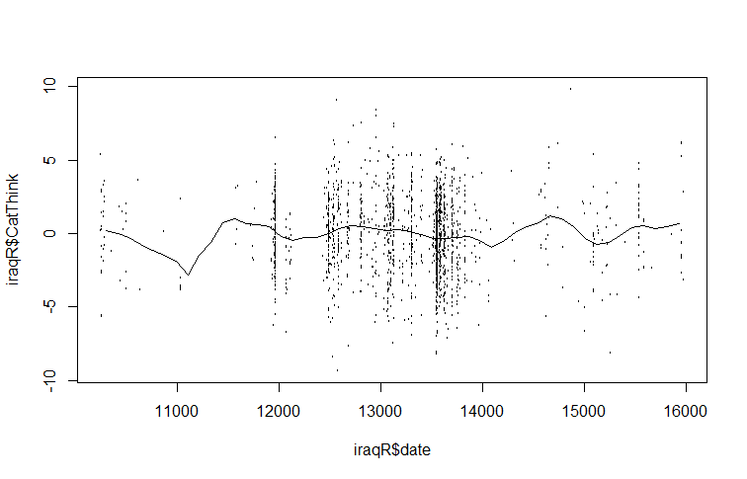

**Iran and North Korea.**

|  |  |  |
| --- | --- | --- |
| Date |  | CatThink |
| 7/16/1998 | 10423.04 | 0.067143 |
| 11/15/1998 | 10545.55 | 0.067143 |
| 7/27/1999 | 10799.99 | -1.07287 |
| 1/23/2000 | 10979.04 | 0.158344 |
| 4/16/2000 | 11063.86 | -0.79927 |
| 12/8/2000 | 11299.46 | 0.705549 |
| 3/12/2001 | 11393.7 | 0.705549 |
| 7/13/2001 | 11516.21 | 1.343955 |
| 7/6/2002 | 11874.31 | -2.03048 |
| 2/17/2003 | 12100.49 | -1.02727 |
| 9/3/2003 | 12298.39 | -1.57447 |
| 5/5/2004 | 12543.41 | 0.203944 |
| 8/17/2004 | 12647.07 | 0.021543 |
| 4/9/2005 | 12882.67 | -1.39207 |
| 3/14/2006 | 13221.93 | 0.477547 |
| 1/1/2007 | 13514.07 | 0.021543 |
| 9/3/2007 | 13759.09 | 0.933551 |
| 7/19/2008 | 14079.5 | -0.52566 |
| 8/28/2009 | 14484.73 | 0.614348 |
| 5/29/2010 | 14758.02 | -0.57126 |
| 10/26/2010 | 14908.81 | -0.16086 |
| 8/14/2011 | 15200.95 | -1.34647 |
| 6/14/2013 | 15870.04 | 4.535987 |

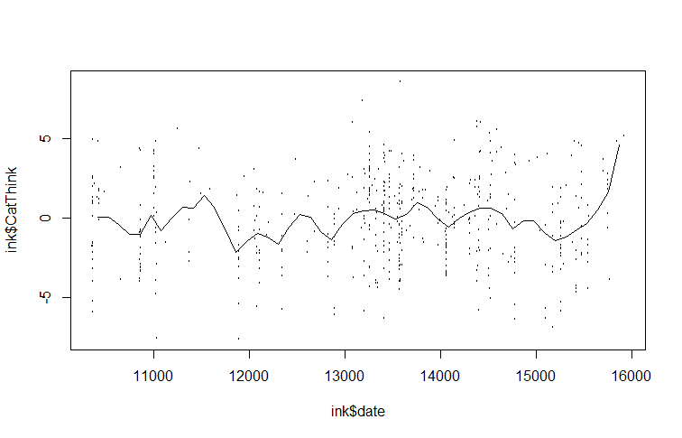

**Democrats**

|  |  |  |
| --- | --- | --- |
| Date |  | CatThink |
| 5/20/1998 | 10366.49 | 0.067143 |
| 9/10/1998 | 10479.58 | 1.389556 |
| 8/15/1999 | 10818.84 | -1.98488 |
| 3/29/2000 | 11045.01 | 0.705549 |
| 6/21/2000 | 11129.83 | 0.067143 |
| 2/21/2001 | 11374.85 | -0.02406 |
| 6/24/2001 | 11497.36 | 0.340746 |
| 5/29/2002 | 11836.62 | -3.30729 |
| 6/10/2003 | 12213.57 | -0.66246 |
| 4/25/2004 | 12533.99 | 1.526357 |
| 3/21/2005 | 12863.82 | -2.07608 |
| 11/2/2005 | 13090 | -0.02406 |
| 2/17/2007 | 13561.19 | 0.203944 |
| 9/3/2007 | 13759.09 | 0.79675 |
| 8/7/2008 | 14098.35 | -0.16086 |
| 11/21/2009 | 14569.55 | 1.298355 |
| 6/16/2010 | 14776.87 | -1.07287 |
| 5/31/2011 | 15125.56 | -2.07608 |
| 8/7/2012 | 15559.05 | -0.57126 |
| 4/18/2013 | 15813.5 | 1.298355 |
| 8/9/2013 | 15926.59 | 4.763989 |

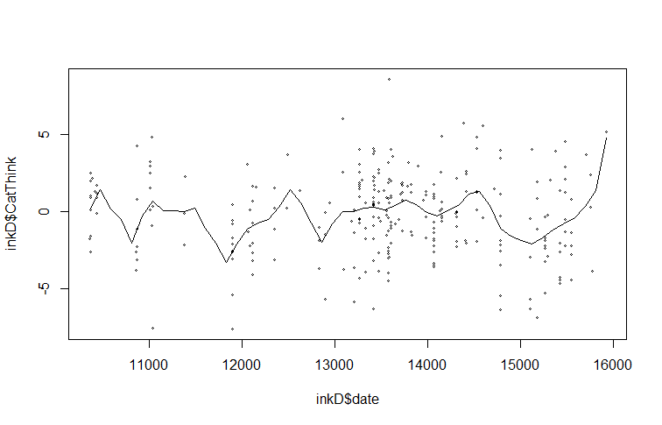

**Republicans**

|  |  |  |
| --- | --- | --- |
| Date |  | CatThink |
| 5/27/1998 | 10373.4 | -1.0096403 |
| 9/15/1998 | 10484.9 | 0.7717117 |
| 8/16/1999 | 10819.4 | -1.4265525 |
| 11/4/2000 | 11265.4 | 1.4160305 |
| 2/23/2001 | 11376.9 | 1.226525 |
| 6/15/2001 | 11488.4 | 1.8708438 |
| 10/14/2001 | 11609.19 | 1.567635 |
| 5/15/2002 | 11822.9 | -1.0854426 |
| 12/15/2002 | 12036.6 | -0.895937 |
| 4/15/2003 | 12157.39 | -1.3128492 |
| 12/12/2003 | 12398.98 | -3.2079046 |
| 11/2/2004 | 12724.18 | -0.4790248 |
| 2/12/2005 | 12826.39 | -0.6306293 |
| 6/3/2005 | 12937.89 | -0.5169259 |
| 2/9/2006 | 13188.77 | 1.0370195 |
| 5/22/2006 | 13290.97 | 1.0370195 |
| 1/10/2007 | 13523.27 | -0.2516182 |
| 4/13/2007 | 13616.18 | -0.5169259 |
| 8/2/2007 | 13727.68 | 1.3781294 |
| 11/22/2007 | 13839.18 | 1.1507228 |
| 7/20/2008 | 14080.76 | -0.8580359 |
| 2/28/2009 | 14303.76 | 0.4306017 |
| 9/11/2009 | 14498.89 | 0.4306017 |
| 12/23/2009 | 14601.09 | 0.4685029 |
| 4/4/2010 | 14703.3 | 0.1273929 |
| 12/29/2010 | 14972.76 | 1.4160305 |
| 7/22/2011 | 15177.18 | -0.6685304 |
| 3/1/2012 | 15400.18 | 0.5822062 |
| 9/21/2012 | 15604.59 | 0.8475139 |
| 1/29/2013 | 15734.67 | 1.9087449 |
| 5/21/2013 | 15846.17 | 4.1828114 |

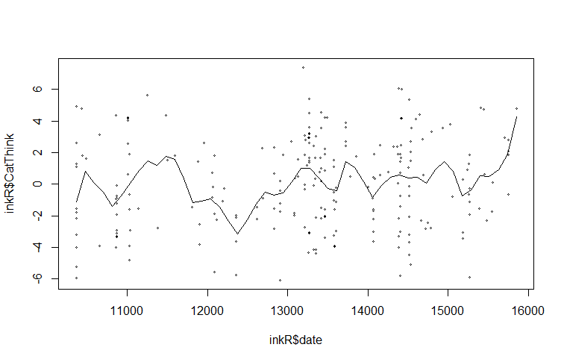

**Complex Thinking**

**Iraq.**

|  |  |  |
| --- | --- | --- |
| Date |  | ComplexThink |
| 3/3/1998 | 10288.81 | 1.5030631 |
| 2/16/1999 | 10638.33 | -0.6630556 |
| 9/27/1999 | 10861.63 | 1.575267 |
| 1/12/2000 | 10968.43 | 0.7088196 |
| 9/20/2000 | 11220.85 | 4.6078332 |
| 5/21/2001 | 11463.57 | -4.5620693 |
| 9/5/2001 | 11570.37 | -0.5186477 |
| 4/6/2002 | 11783.96 | -1.2406873 |
| 8/20/2002 | 11919.88 | 1.2864512 |
| 7/26/2003 | 12259.69 | 1.5030631 |
| 11/20/2003 | 12376.19 | 2.8749383 |
| 3/25/2004 | 12502.41 | 0.4922077 |
| 11/13/2004 | 12735.42 | 0.1311879 |
| 1/30/2005 | 12813.09 | -0.8074635 |
| 8/16/2006 | 13376.19 | -0.4464438 |
| 1/8/2007 | 13521.83 | 0.3477998 |
| 5/24/2007 | 13657.75 | -0.5908517 |
| 12/14/2007 | 13861.63 | -0.5186477 |
| 4/9/2008 | 13978.14 | -1.3128912 |
| 8/23/2008 | 14114.06 | -1.3128912 |
| 11/28/2008 | 14211.15 | -1.746115 |
| 3/24/2009 | 14327.65 | -0.3020358 |
| 3/9/2010 | 14677.17 | -1.3850952 |
| 6/4/2010 | 14764.54 | -2.9735822 |
| 2/11/2011 | 15016.97 | 1.647471 |
| 5/29/2011 | 15123.77 | -0.3020358 |
| 9/23/2011 | 15240.27 | -0.085424 |
| 1/27/2012 | 15366.49 | -2.0349308 |
| 9/16/2012 | 15599.5 | -0.6630556 |
| 12/12/2012 | 15686.87 | -2.0349308 |
| 4/8/2013 | 15803.38 | -1.0240754 |
| 8/22/2013 | 15939.3 | -2.2515427 |

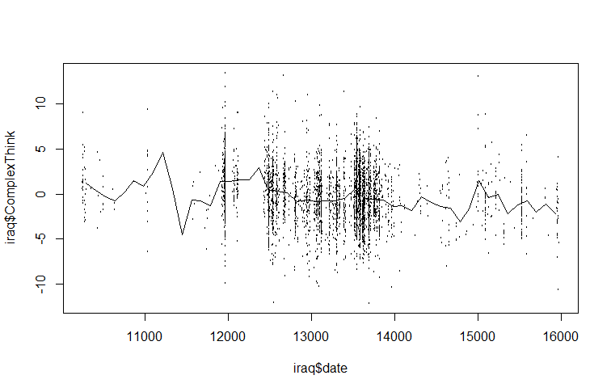

**Democrats**

|  |  |  |
| --- | --- | --- |
| Date |  | ComplexThink |
| 3/19/1998 | 10304.71 | 1.50306309 |
| 8/2/1998 | 10440.26 | 1.79187891 |
| 11/16/1998 | 10546.75 | -1.24068728 |
| 3/12/1999 | 10662.93 | -1.67391102 |
| 6/29/2000 | 11137.33 | 2.6583264 |
| 10/4/2000 | 11234.15 | 2.00849079 |
| 1/21/2002 | 11708.55 | 2.36951057 |
| 4/28/2002 | 11805.36 | 2.94714223 |
| 10/9/2002 | 11969.95 | 1.79187891 |
| 12/19/2003 | 12405.62 | -0.44644375 |
| 4/23/2004 | 12531.49 | 1.21424726 |
| 4/7/2005 | 12880.02 | -0.37423979 |
| 2/20/2006 | 13199.52 | -0.22983188 |
| 9/21/2006 | 13412.51 | -0.59085166 |
| 1/25/2007 | 13538.37 | -0.22983188 |
| 5/21/2007 | 13654.55 | -0.80746353 |
| 8/26/2007 | 13751.37 | -0.30203584 |
| 12/12/2008 | 14225.77 | -1.96272684 |
| 4/7/2009 | 14341.95 | -0.30203584 |
| 11/26/2009 | 14574.31 | -2.46815454 |
| 3/3/2010 | 14671.12 | -2.17933872 |
| 6/27/2010 | 14787.3 | -4.12884555 |
| 2/14/2011 | 15019.66 | 3.09155014 |
| 1/29/2012 | 15368.2 | -3.47900994 |
| 5/14/2012 | 15474.7 | -3.40680598 |
| 9/17/2012 | 15600.56 | -0.01322001 |
| 1/2/2013 | 15707.05 | -0.59085166 |
| 4/28/2013 | 15823.23 | 0.56441165 |
| 9/10/2013 | 15958.78 | -2.46815454 |

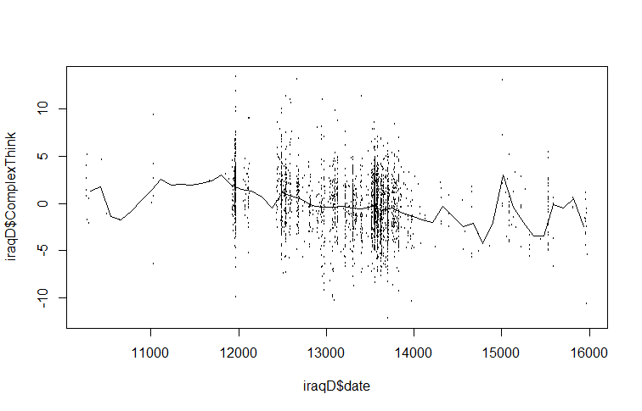

**Republicans**

|  |  |  |
| --- | --- | --- |
| Date |  | ComplexThink |
| 4/1/1998 | 10317.9 | 1.29377707 |
| 7/27/1998 | 10434.32 | -0.14961829 |
| 10/12/1998 | 10511.93 | 0.22691963 |
| 2/6/1999 | 10628.36 | -0.52615621 |
| 6/22/1999 | 10764.19 | -0.08686197 |
| 10/6/1999 | 10870.91 | 1.48204603 |
| 5/26/2000 | 11103.75 | 1.29377707 |
| 1/24/2001 | 11346.3 | 0.10140699 |
| 5/11/2001 | 11453.02 | -2.03230789 |
| 10/3/2001 | 11598.55 | -0.77718149 |
| 12/29/2001 | 11685.87 | -1.53025733 |
| 4/5/2002 | 11782.89 | -1.53025733 |
| 8/10/2002 | 11909.02 | 1.23102075 |
| 12/14/2002 | 12035.14 | 0.79172651 |
| 4/9/2003 | 12151.57 | 2.23512187 |
| 11/18/2003 | 12374.71 | -2.15782053 |
| 3/14/2004 | 12491.13 | -0.90269413 |
| 10/13/2004 | 12704.58 | -0.52615621 |
| 2/16/2005 | 12830.7 | -1.46750101 |
| 10/7/2005 | 13063.55 | -0.83993781 |
| 1/31/2006 | 13179.97 | -1.65576997 |
| 8/14/2006 | 13374.01 | -0.58891253 |
| 1/16/2007 | 13529.24 | 1.16826443 |
| 5/2/2007 | 13635.97 | 0.03865067 |
| 9/15/2007 | 13771.79 | -0.02410565 |
| 12/2/2007 | 13849.41 | -0.52615621 |
| 4/6/2008 | 13975.53 | -0.21237461 |
| 7/22/2008 | 14082.26 | -1.59301365 |
| 11/25/2008 | 14208.38 | -1.15371941 |
| 3/21/2009 | 14324.8 | -0.21237461 |
| 9/2/2009 | 14489.74 | -0.58891253 |
| 10/30/2009 | 14547.95 | -1.34198837 |
| 3/6/2010 | 14674.08 | -0.46339989 |
| 6/20/2010 | 14780.8 | -2.40884581 |
| 2/8/2011 | 15013.64 | 0.22691963 |
| 5/16/2011 | 15110.66 | -0.40064357 |
| 10/18/2011 | 15265.89 | 0.60345755 |
| 1/4/2012 | 15343.51 | -1.21647573 |
| 1/7/2013 | 15712.18 | 0.03865067 |
| 4/14/2013 | 15809.2 | -3.60121589 |
| 8/8/2013 | 15925.63 | -2.03230789 |

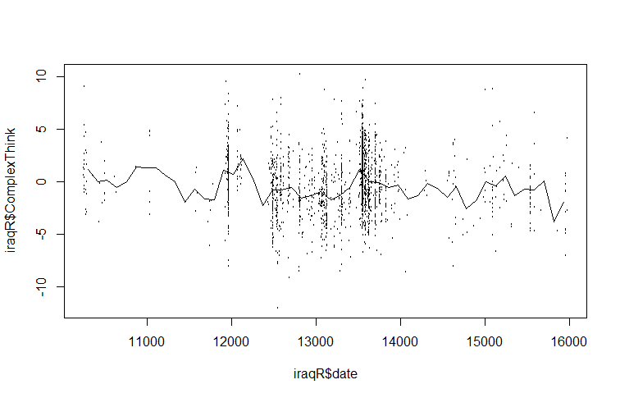

**Iran and North Korea.**

|  |  |  |
| --- | --- | --- |
| Date |  | ComplexThink |
| 7/16/1998 | 10423.04 | 0.6551 |
| 4/24/1999 | 10705.75 | 1.4635981 |
| 1/23/2000 | 10979.04 | 1.0088179 |
| 6/24/2001 | 11497.36 | 0.4024443 |
| 6/26/2002 | 11864.89 | 2.5247518 |
| 8/6/2003 | 12270.12 | -0.4565849 |
| 7/29/2004 | 12628.23 | -1.1640207 |
| 3/12/2005 | 12854.4 | 0.0487264 |
| 12/10/2005 | 13127.69 | -0.7597717 |
| 5/3/2007 | 13636.58 | 0.2508509 |
| 8/26/2008 | 14117.2 | 0.5035066 |
| 9/26/2009 | 14513 | -0.860834 |
| 5/29/2010 | 14758.02 | 0.5540377 |
| 5/22/2011 | 15116.13 | -0.4565849 |
| 3/28/2012 | 15427.12 | 0.1497887 |
| 12/26/2012 | 15700.41 | -1.1134896 |
| 6/14/2013 | 15870.04 | -2.8820792 |

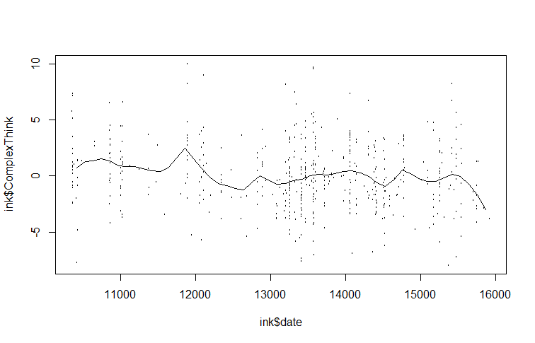

**Democrats**

|  |  |  |
| --- | --- | --- |
| Date |  | ComplexThink |
| 5/11/1998 | 10357.07 | 1.5141292 |
| 9/1/1998 | 10470.15 | 0.14978866 |
| 9/3/1999 | 10837.69 | 2.32262729 |
| 2/29/2000 | 11016.74 | 1.5141292 |
| 2/12/2001 | 11365.42 | 1.10988015 |
| 5/20/2002 | 11827.19 | 5.20290174 |
| 12/16/2003 | 12402.05 | -0.2544604 |
| 11/28/2004 | 12750.74 | 0.95828676 |
| 10/24/2005 | 13080.57 | -0.0523359 |
| 9/19/2006 | 13410.41 | -0.2544604 |
| 6/19/2007 | 13683.7 | 0.50350658 |
| 4/6/2008 | 13975.84 | 0.85722449 |
| 1/23/2009 | 14267.98 | 0.7056311 |
| 7/12/2009 | 14437.61 | -0.4060538 |
| 10/5/2009 | 14522.43 | -0.8103028 |
| 6/7/2010 | 14767.45 | 1.31200467 |
| 5/22/2011 | 15116.13 | -0.2544604 |
| 9/12/2011 | 15229.22 | -0.3049915 |
| 5/4/2012 | 15464.82 | 0.50350658 |
| 7/31/2013 | 15917.16 | -3.3873905 |

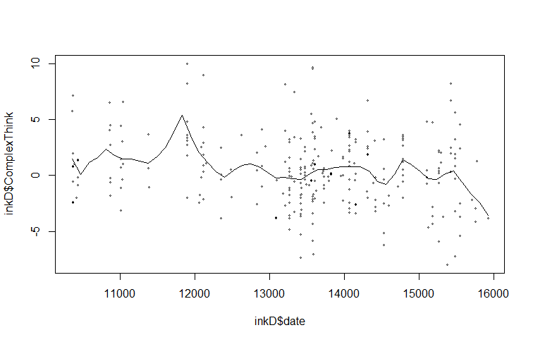

**Republicans**

|  |  |  |
| --- | --- | --- |
| Date |  | ComplexThink |
| 6/5/1998 | 10382.69 | 1.36961278 |
| 9/15/1998 | 10484.9 | 0.35686235 |
| 7/28/1999 | 10800.82 | 1.41181072 |
| 2/27/2000 | 11014.52 | 0.27246649 |
| 7/13/2001 | 11516.27 | -0.36050253 |
| 12/18/2001 | 11674.23 | -1.12006535 |
| 10/20/2002 | 11980.85 | -0.40270047 |
| 11/15/2003 | 12371.1 | -1.24665915 |
| 6/15/2004 | 12584.81 | -2.47039925 |
| 10/5/2004 | 12696.31 | -2.17501371 |
| 6/13/2005 | 12947.18 | -0.5714922 |
| 1/12/2006 | 13160.89 | -1.12006535 |
| 3/16/2007 | 13588.31 | -0.06511699 |
| 7/5/2007 | 13699.81 | -0.74028394 |
| 7/20/2008 | 14080.76 | -0.27610666 |
| 3/26/2010 | 14694.01 | -0.95127361 |
| 8/12/2010 | 14833.39 | -1.33105502 |
| 7/22/2011 | 15177.18 | -0.19171079 |
| 7/9/2012 | 15530.26 | -0.27610666 |
| 5/21/2013 | 15846.17 | -2.38600338 |

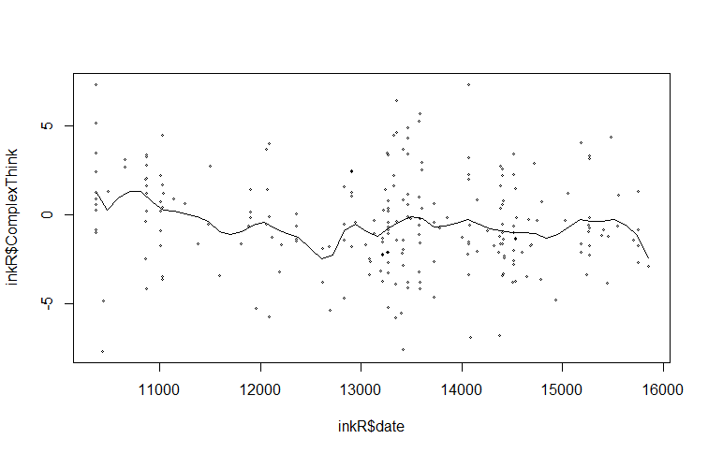

**Cognitive Processing**

**Iraq.**

|  |  |  |
| --- | --- | --- |
| Date |  | CogProcess |
| 2/22/1998 | 10279.11 | 0.8444967 |
| 1/27/1999 | 10618.91 | 0.3994886 |
| 9/27/1999 | 10861.63 | 0.7418025 |
| 1/31/2000 | 10987.84 | 0.3310258 |
| 9/20/2000 | 11220.85 | 2.2479838 |
| 1/25/2001 | 11347.07 | 0.0571747 |
| 5/11/2001 | 11453.86 | -0.5932217 |
| 12/11/2001 | 11667.46 | -1.0039984 |
| 4/26/2002 | 11803.38 | 0.3994886 |
| 12/5/2002 | 12026.68 | 1.0156537 |
| 4/1/2003 | 12143.18 | -0.2851392 |
| 11/29/2003 | 12385.9 | 0.8444967 |
| 5/22/2004 | 12560.66 | 0.0571747 |
| 2/18/2005 | 12832.5 | -0.6274531 |
| 1/4/2006 | 13152.89 | -0.4220648 |
| 5/20/2006 | 13288.82 | -0.2166764 |
| 8/6/2006 | 13366.49 | -0.1482137 |
| 2/26/2007 | 13570.37 | 0.3310258 |
| 4/25/2007 | 13628.62 | -0.5589904 |
| 9/18/2007 | 13774.25 | -0.1482137 |
| 4/9/2008 | 13978.14 | -0.4562962 |
| 8/3/2008 | 14094.64 | -0.3193706 |
| 11/8/2008 | 14191.73 | -1.0382298 |
| 3/24/2009 | 14327.65 | -0.0112881 |
| 7/9/2009 | 14434.45 | -0.4905276 |
| 11/22/2009 | 14570.37 | -0.1139823 |
| 3/28/2010 | 14696.58 | -0.7643787 |
| 7/3/2010 | 14793.67 | -1.7228577 |
| 10/18/2010 | 14900.47 | -1.6543949 |
| 2/2/2011 | 15007.26 | 0.3652572 |
| 5/29/2011 | 15123.77 | -0.524759 |
| 10/2/2011 | 15249.98 | -0.4220648 |
| 1/17/2012 | 15356.78 | -1.5174693 |
| 5/22/2012 | 15482.99 | -0.5589904 |
| 9/26/2012 | 15609.2 | -0.5589904 |
| 1/11/2013 | 15716 | -2.3390227 |
| 4/18/2013 | 15813.09 | -0.0112881 |
| 8/2/2013 | 15919.88 | -0.4562962 |

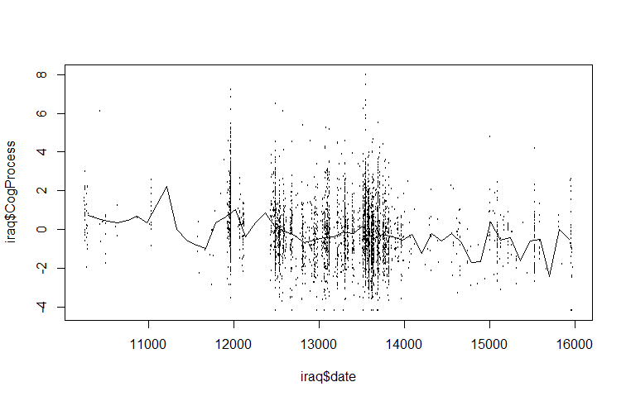

**Democrats**

|  |  |  |
| --- | --- | --- |
| Date |  | CogProcess |
| 3/19/1998 | 10304.71 | 1.118348 |
| 7/23/1998 | 10430.58 | 4.678413 |
| 11/26/1998 | 10556.44 | 0.057175 |
| 3/3/1999 | 10653.25 | -0.21668 |
| 10/21/1999 | 10885.61 | 0.399489 |
| 3/5/2000 | 11021.15 | 0.022943 |
| 5/5/2001 | 11447.14 | 0.022943 |
| 9/17/2001 | 11582.69 | -2.95519 |
| 5/8/2002 | 11815.05 | 3.309157 |
| 12/26/2002 | 12047.4 | 0.331026 |
| 10/22/2003 | 12347.53 | -0.49053 |
| 3/25/2004 | 12502.44 | 0.43372 |
| 7/9/2004 | 12608.94 | -0.04552 |
| 6/13/2005 | 12947.79 | -0.38783 |
| 4/29/2006 | 13267.29 | -0.01129 |
| 8/23/2006 | 13383.47 | -0.18245 |
| 1/6/2007 | 13519.01 | -0.04552 |
| 6/9/2007 | 13673.92 | -0.38783 |
| 9/24/2007 | 13780.41 | -0.18245 |
| 12/20/2007 | 13867.55 | -0.73015 |
| 7/30/2008 | 14090.22 | -0.38783 |
| 11/4/2008 | 14187.04 | -1.38054 |
| 3/9/2009 | 14312.9 | -0.14821 |
| 8/2/2009 | 14458.13 | -0.49053 |
| 11/16/2009 | 14564.62 | -0.18245 |
| 2/21/2010 | 14661.44 | -0.38783 |
| 7/6/2010 | 14796.98 | -1.89401 |
| 10/31/2010 | 14913.16 | -1.68863 |
| 2/14/2011 | 15019.66 | 0.331026 |
| 4/15/2012 | 15445.65 | -2.33902 |
| 8/29/2012 | 15581.19 | 0.159869 |
| 11/24/2012 | 15668.33 | 0.159869 |
| 4/18/2013 | 15813.55 | 0.639108 |
| 8/22/2013 | 15939.41 | -0.49053 |

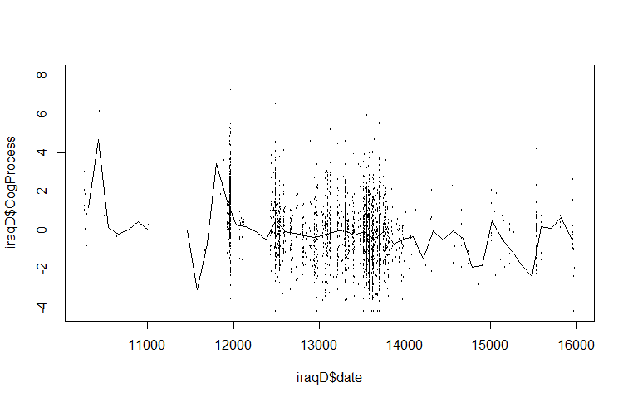

**Republicans**

|  |  |  |
| --- | --- | --- |
| Date |  | CogProcess |
| 4/11/1998 | 10327.6 | 0.624126 |
| 10/12/1998 | 10511.93 | -0.12868 |
| 2/6/1999 | 10628.36 | 0.853241 |
| 6/22/1999 | 10764.19 | 1.049625 |
| 10/6/1999 | 10870.91 | 0.656856 |
| 6/24/2000 | 11132.86 | 0.853241 |
| 5/1/2001 | 11443.32 | -0.65237 |
| 12/10/2001 | 11666.47 | -1.01241 |
| 8/10/2002 | 11909.02 | 1.115086 |
| 4/19/2003 | 12161.27 | -0.16141 |
| 11/18/2003 | 12374.71 | -3.46721 |
| 3/23/2004 | 12500.84 | -0.12868 |
| 10/13/2004 | 12704.58 | -0.55418 |
| 2/7/2005 | 12821 | -0.91422 |
| 10/26/2005 | 13082.95 | -0.61964 |
| 1/12/2006 | 13160.57 | -0.61964 |
| 5/18/2006 | 13286.69 | -0.39053 |
| 8/4/2006 | 13364.31 | -0.39053 |
| 12/18/2006 | 13500.14 | 0.264088 |
| 5/2/2007 | 13635.97 | -0.19414 |
| 9/6/2007 | 13762.09 | -0.09595 |
| 12/21/2007 | 13868.81 | -0.32506 |
| 4/6/2008 | 13975.53 | -0.06322 |
| 7/31/2008 | 14091.96 | -0.55418 |
| 11/25/2008 | 14208.38 | -0.75056 |
| 3/21/2009 | 14324.8 | -0.58691 |
| 2/24/2010 | 14664.37 | -0.61964 |
| 6/20/2010 | 14780.8 | -1.27425 |
| 2/18/2011 | 15023.35 | 0.067704 |
| 6/5/2011 | 15130.07 | -0.52145 |
| 9/10/2011 | 15227.09 | -0.42326 |
| 1/14/2012 | 15353.21 | -1.24152 |
| 4/29/2012 | 15459.93 | 0.034974 |
| 8/24/2012 | 15576.36 | -0.65237 |
| 12/9/2012 | 15683.08 | -0.94695 |
| 4/23/2013 | 15818.91 | -1.92887 |
| 8/8/2013 | 15925.63 | -0.6851 |

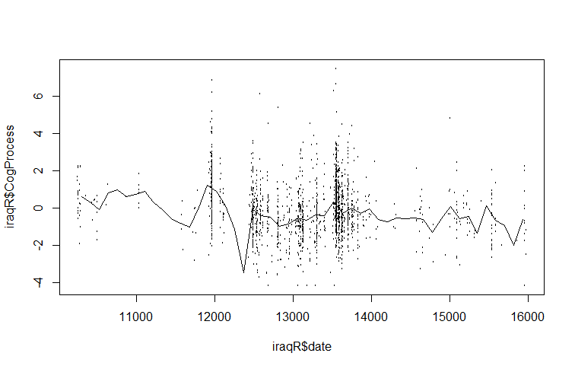

**Iran and North Korea.**

|  |  |  |
| --- | --- | --- |
| Date |  | CogProcess |
| 7/16/1998 | 10423.04 | 0.129476 |
| 7/27/1999 | 10799.99 | 0.321906 |
| 1/15/2001 | 11337.15 | 0.047005 |
| 12/10/2001 | 11666.99 | 0.404376 |
| 8/13/2002 | 11912.01 | 0.816728 |
| 10/1/2003 | 12326.66 | 0.074495 |
| 2/21/2005 | 12835.55 | -0.06296 |
| 1/17/2006 | 13165.39 | -0.20041 |
| 6/10/2007 | 13674.28 | 0.211946 |
| 6/11/2008 | 14041.81 | 0.266926 |
| 9/7/2009 | 14494.16 | -0.31037 |
| 2/16/2011 | 15021.89 | 0.074495 |
| 5/4/2012 | 15464.82 | 0.459357 |
| 5/26/2013 | 15851.2 | -0.36535 |

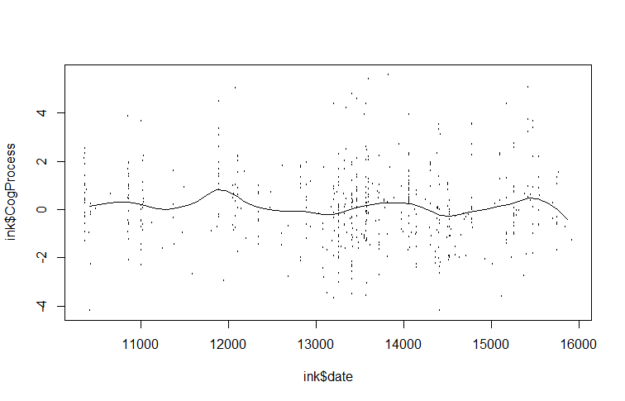

**Democrats**

|  |  |  |
| --- | --- | --- |
| Date |  | CogProcess |
| 6/8/1998 | 10385.34 | 0.3768864 |
| 9/13/1999 | 10847.11 | 0.4868467 |
| 8/26/2000 | 11195.79 | 0.2394359 |
| 8/29/2001 | 11563.33 | 0.8991982 |
| 5/29/2002 | 11836.62 | 1.7788812 |
| 3/8/2003 | 12119.34 | 1.0091585 |
| 11/8/2003 | 12364.36 | 0.4868467 |
| 2/21/2005 | 12835.55 | 0.3768864 |
| 4/2/2006 | 13240.78 | -0.062955 |
| 3/9/2008 | 13947.57 | 0.4043765 |
| 7/31/2009 | 14456.46 | -0.200406 |
| 6/26/2010 | 14786.3 | 0.3768864 |
| 7/8/2011 | 15163.25 | 0.5968071 |
| 6/30/2012 | 15521.36 | 0.6792774 |
| 3/2/2013 | 15766.38 | 0.1294755 |
| 8/9/2013 | 15926.59 | -0.585267 |

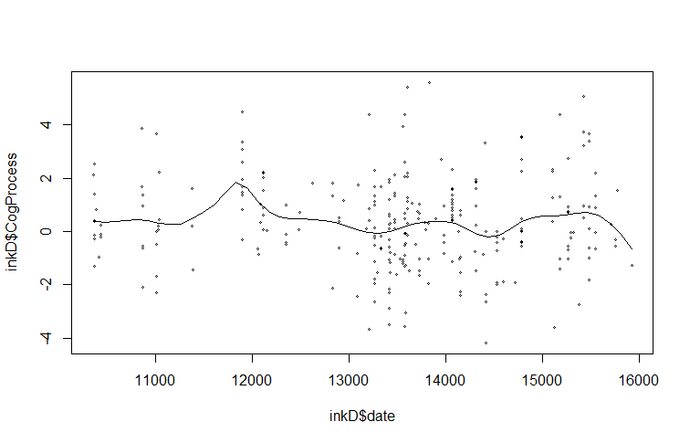

**Republicans**

|  |  |  |
| --- | --- | --- |
| Date |  | CogProcess |
| 6/5/1998 | 10382.69 | 0.0348658 |
| 9/22/1999 | 10856.57 | 0.2679319 |
| 9/7/2001 | 11572.02 | -0.6384365 |
| 1/31/2003 | 12083.06 | 0.060762 |
| 6/25/2004 | 12594.1 | -0.483059 |
| 5/7/2005 | 12910.02 | -0.3535778 |
| 1/3/2006 | 13151.6 | -0.4571628 |
| 12/13/2006 | 13495.39 | 0.164347 |
| 7/30/2008 | 14090.06 | 0.060762 |
| 4/4/2010 | 14703.3 | -0.6643327 |
| 6/15/2011 | 15140.01 | -0.4053703 |
| 5/23/2012 | 15483.8 | 0.1125545 |
| 5/11/2013 | 15836.88 | -0.2758891 |

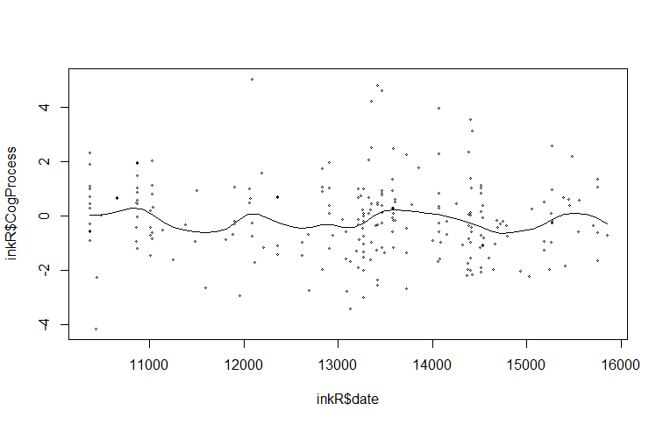

**Psychological Distancing**

**Iraq.**

|  |  |  |
| --- | --- | --- |
| Date |  | PsychDistance |
| 3/13/1998 | 10298.52 | 1.4097015 |
| 10/3/1998 | 10502.41 | 0.8442575 |
| 3/7/1999 | 10657.75 | 0.7634798 |
| 2/20/2000 | 11007.26 | -3.3561835 |
| 5/27/2000 | 11104.35 | -6.6680697 |
| 8/16/2001 | 11550.95 | 0.6827021 |
| 10/22/2003 | 12347.07 | 0.5211467 |
| 9/20/2005 | 13046.1 | 0.8442575 |
| 1/8/2007 | 13521.83 | -0.2058528 |
| 2/10/2008 | 13919.88 | -0.125075 |
| 3/5/2009 | 14308.23 | 1.0058129 |
| 2/8/2010 | 14648.04 | 1.9751455 |
| 6/27/2011 | 15152.89 | 0.4403689 |
| 6/30/2012 | 15521.83 | 0.4403689 |
| 8/12/2013 | 15929.59 | 0.9250352 |

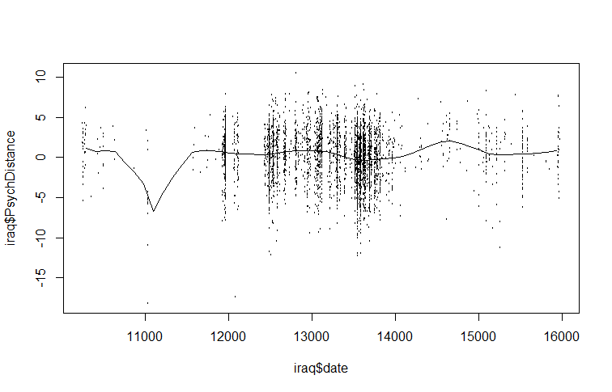

**Democrats**

|  |  |  |
| --- | --- | --- |
| Date |  | PsychDistance |
| 3/19/1998 | 10304.71 | 2.70516263 |
| 8/2/1998 | 10440.26 | 1.17228336 |
| 3/3/1999 | 10653.25 | 0.17591184 |
| 6/9/2000 | 11117.97 | -7.18190865 |
| 10/13/2000 | 11243.83 | -4.88258975 |
| 9/17/2001 | 11582.69 | -2.65991481 |
| 4/9/2002 | 11786 | 0.17591184 |
| 9/10/2002 | 11940.91 | 0.86570751 |
| 3/6/2004 | 12483.08 | -0.20730798 |
| 12/21/2004 | 12773.53 | 0.71241958 |
| 2/10/2006 | 13189.83 | 0.94235147 |
| 3/5/2007 | 13577.1 | 0.02262391 |
| 6/11/2008 | 14041.82 | 0.48248769 |
| 3/9/2009 | 14312.9 | 1.24892733 |
| 2/21/2010 | 14661.44 | 3.24167038 |
| 5/22/2011 | 15116.48 | 0.71241958 |
| 4/25/2012 | 15455.33 | 0.40584373 |
| 10/6/2012 | 15619.92 | -0.05402005 |
| 9/10/2013 | 15958.78 | 0.32919977 |

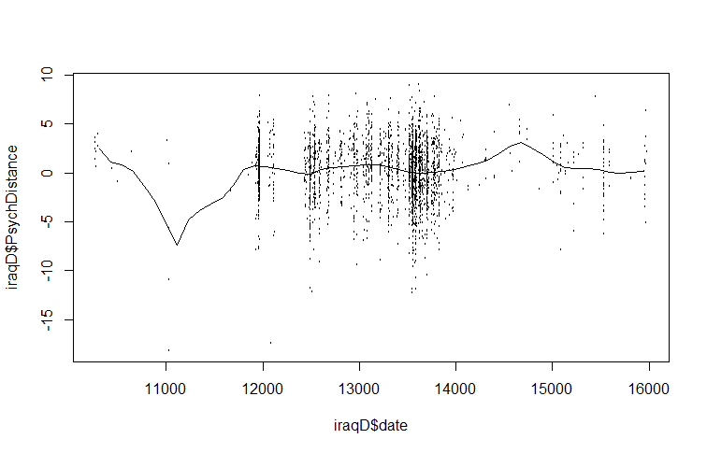

**Republicans**

|  |  |  |
| --- | --- | --- |
| Date |  | PsychDistance |
| 3/3/1998 | 10288.79 | 0.5820969 |
| 11/20/1998 | 10550.74 | 0.7042608 |
| 5/26/2000 | 11103.75 | -4.4266248 |
| 9/4/2001 | 11569.45 | 0.5210149 |
| 3/7/2002 | 11753.79 | 0.9485887 |
| 12/4/2002 | 12025.44 | 0.276687 |
| 9/4/2004 | 12665.77 | 1.0707526 |
| 7/31/2005 | 12995.64 | 0.8264248 |
| 2/20/2006 | 13199.38 | 0.7042608 |
| 2/14/2007 | 13558.35 | -0.7617065 |
| 7/2/2008 | 14062.85 | -0.6395426 |
| 4/19/2009 | 14353.91 | 0.7042608 |
| 2/24/2010 | 14664.37 | 1.5594084 |
| 1/20/2011 | 14994.24 | 1.0096707 |
| 9/10/2011 | 15227.09 | 0.0934411 |
| 7/29/2013 | 15915.93 | 1.7426543 |

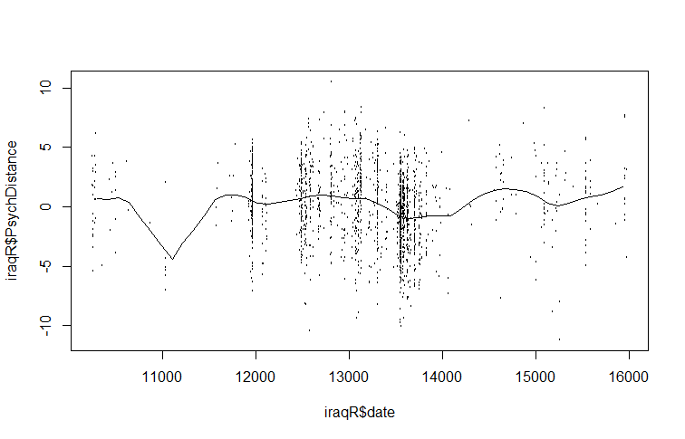

**Iran and North Korea.**

|  |  |  |
| --- | --- | --- |
| Date |  | PsychDistance |
| 8/3/1998 | 10441.88 | 0.05253415 |
| 11/6/1998 | 10536.12 | 0.11475198 |
| 6/10/1999 | 10752.87 | -2.43617878 |
| 9/13/1999 | 10847.11 | -2.37396095 |
| 1/23/2000 | 10979.04 | 0.23918762 |
| 4/26/2000 | 11073.28 | -2.12508966 |
| 12/27/2000 | 11318.3 | 1.79463321 |
| 4/9/2001 | 11421.97 | -0.6318619 |
| 8/1/2001 | 11535.05 | 1.11023715 |
| 11/3/2001 | 11629.29 | 0.42584109 |
| 6/26/2002 | 11864.89 | -3.61831742 |
| 2/17/2003 | 12100.49 | -1.00516884 |
| 5/22/2003 | 12194.73 | -1.19182231 |
| 9/3/2003 | 12298.39 | -2.43617878 |
| 4/25/2004 | 12533.99 | 1.2346728 |
| 4/9/2005 | 12882.67 | -2.62283225 |
| 11/12/2005 | 13099.42 | 1.17245497 |
| 3/5/2006 | 13212.51 | 0.48805892 |
| 9/28/2006 | 13419.83 | 0.05253415 |
| 1/19/2007 | 13532.92 | -1.25404014 |
| 5/13/2007 | 13646.01 | -1.06738667 |
| 9/3/2007 | 13759.09 | 0.9858015 |
| 12/6/2007 | 13853.33 | 1.29689062 |
| 7/19/2008 | 14079.5 | -1.00516884 |
| 2/2/2009 | 14277.41 | -0.25855496 |
| 5/26/2009 | 14390.49 | 0.9858015 |
| 9/26/2009 | 14513 | 1.35910844 |
| 1/17/2010 | 14626.09 | 0.86136586 |
| 5/10/2010 | 14739.18 | -1.56512925 |
| 12/22/2010 | 14965.35 | 1.17245497 |
| 8/5/2011 | 15191.52 | -1.93843619 |
| 7/28/2012 | 15549.63 | -0.8807332 |
| 3/2/2013 | 15766.38 | 1.42132627 |
| 6/4/2013 | 15860.62 | 4.84330655 |

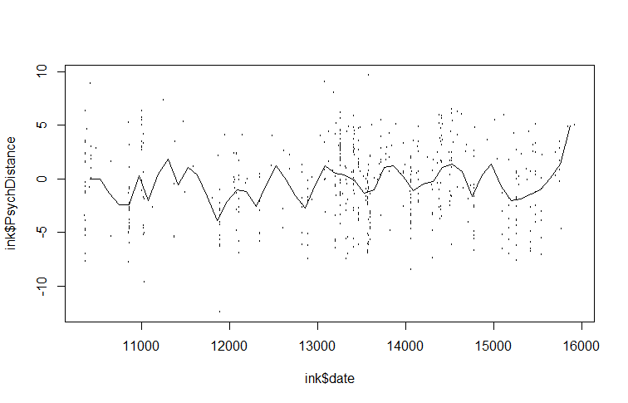

**Democrats**

|  |  |  |
| --- | --- | --- |
| Date |  | PsychDistance |
| 5/11/1998 | 10357.07 | -0.38299061 |
| 9/10/1998 | 10479.58 | 2.54124708 |
| 8/15/1999 | 10818.84 | -5.79594124 |
| 4/7/2000 | 11054.44 | 0.11475198 |
| 7/10/2000 | 11148.67 | -1.81400055 |
| 11/29/2000 | 11290.03 | -0.94295102 |
| 3/3/2001 | 11384.27 | -1.44069361 |
| 4/9/2001 | 11421.97 | 10.62956411 |
| 9/26/2001 | 11591.6 | 10.50512847 |
| 10/24/2001 | 11619.87 | -2.43617878 |
| 5/29/2002 | 11836.62 | -6.29368382 |
| 1/20/2003 | 12072.22 | -1.44069361 |
| 4/15/2003 | 12157.03 | -1.00516884 |
| 8/24/2003 | 12288.97 | -1.31625796 |
| 12/6/2003 | 12392.63 | -0.32077279 |
| 4/25/2004 | 12533.99 | 2.47902926 |
| 8/17/2004 | 12647.07 | 1.85685103 |
| 3/31/2005 | 12873.25 | -3.24501048 |
| 11/12/2005 | 13099.42 | 1.29689062 |
| 2/24/2006 | 13203.08 | -0.19633714 |
| 10/27/2006 | 13448.1 | 0.05253415 |
| 1/29/2007 | 13542.34 | -1.06738667 |
| 5/31/2007 | 13664.85 | -0.56964408 |
| 8/15/2007 | 13740.24 | 0.61249456 |
| 1/13/2008 | 13891.03 | 0.79914803 |
| 6/30/2008 | 14060.66 | -0.6318619 |
| 3/30/2009 | 14333.95 | -1.12960449 |
| 7/12/2009 | 14437.61 | 1.11023715 |
| 11/12/2009 | 14560.12 | 1.73241538 |
| 6/16/2010 | 14776.87 | -2.31174313 |
| 9/12/2011 | 15229.22 | -2.93392136 |
| 2/19/2012 | 15389.42 | -2.12508966 |
| 5/14/2012 | 15474.24 | -1.75178272 |
| 8/7/2012 | 15559.05 | -2.06287184 |
| 4/18/2013 | 15813.5 | 0.55027674 |
| 8/9/2013 | 15926.59 | 5.09217784 |

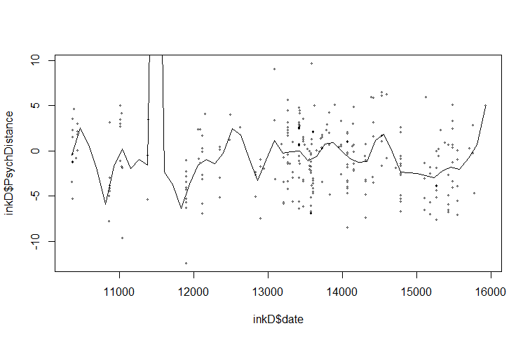

**Republicans**

|  |  |  |
| --- | --- | --- |
| Date |  | PsychDistance |
| 5/27/1998 | 10373.4 | -1.3456509 |
| 9/25/1998 | 10494.19 | 2.3872277 |
| 3/11/1999 | 10661.44 | -1.1590069 |
| 8/16/1999 | 10819.4 | -2.2788705 |
| 3/17/2000 | 11033.11 | -0.2257873 |
| 11/4/2000 | 11265.4 | 2.3872277 |
| 2/23/2001 | 11376.9 | -0.4124312 |
| 6/15/2001 | 11488.4 | 0.7540933 |
| 10/4/2001 | 11599.9 | 0.9873982 |
| 5/25/2002 | 11832.19 | -1.7655997 |
| 1/3/2003 | 12055.19 | -0.6923971 |
| 5/3/2003 | 12175.98 | -1.065685 |
| 11/15/2003 | 12371.1 | -4.0986488 |
| 7/4/2004 | 12603.39 | -2.8854633 |
| 10/23/2004 | 12714.89 | -0.7390581 |
| 2/12/2005 | 12826.39 | -1.5789558 |
| 6/3/2005 | 12937.89 | -1.3456509 |
| 1/22/2006 | 13170.18 | 1.7806349 |
| 9/11/2006 | 13402.47 | 0.1008396 |
| 4/13/2007 | 13616.18 | -1.6722777 |
| 8/2/2007 | 13727.68 | 2.2005838 |
| 10/25/2007 | 13811.31 | 2.3405667 |
| 7/2/2008 | 14062.18 | -1.2056679 |
| 10/21/2008 | 14173.68 | 0.8940763 |
| 3/19/2009 | 14322.35 | 1.4073471 |
| 9/11/2009 | 14498.89 | 1.2673641 |
| 1/1/2010 | 14610.39 | 1.500669 |
| 5/11/2010 | 14740.47 | 0.7074323 |
| 12/11/2010 | 14954.18 | 3.1804644 |
| 3/23/2011 | 15056.39 | 2.3405667 |
| 7/22/2011 | 15177.18 | -0.5057532 |
| 11/19/2011 | 15297.97 | -0.2257873 |
| 3/1/2012 | 15400.18 | 0.9407373 |
| 6/11/2012 | 15502.38 | 0.4274665 |
| 11/16/2012 | 15660.34 | 1.4073471 |
| 3/7/2013 | 15771.84 | 2.9471595 |
| 5/30/2013 | 15855.47 | 4.8135988 |

